Creating chatbots with Google Dialogflow

1. **Chatbot Fundamentals**
   1. **What is a chatbot?**

**It is a application which understands user needs and based on that it responds accordongly.**

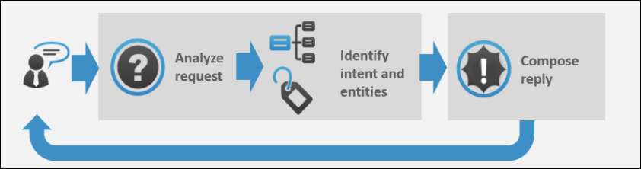

Image Courtesy: <https://expertsystem.com/chatbot/>

**Broadly, chatbots can be classified into two categories:**

1. **Rule-Based Chatbots: these are based on if else statemnts.**
2. **Chatbots with Natural Language Understanding: these are used to understands query of user**
   1. **Uses of chatbots:**
3. **Can be used to answer FAQs.**
4. **Can be used for grievance handling.**
5. **Internal organizational automation.**
6. **To do the flight, hotel, appointment bookings etc.**
7. **Can guide customers to buy the correct product by answering their questions**
8. **Can be used for Customer Relationship Management.**
9. **Can be used to book an appoinment**
   1. **Advantages of Chatbots**
10. **24*7 customer support.**
11. **Understands user**
12. **Cost-efficient.**
13. **Build once and deploy everywhere.**
14. **Integration with various channels and platforms**
15. **Better monitoring and insight generation.**
    1. **Frameworks Present in the Market:**
16. **Google Dialogflow: It is NLP based platform which understands user query**
17. **Microsoft Bot Builder with LUIS: NLP based platform.**
18. **Amazon Lex: Amazon based NLP platform**
19. **RASA: Rasa provides infrastructure & tools necessary for high-performing, resilient, proprietary contextual assistants that work.**
20. **Wit.ai (Facebook):** **Wit.ai makes it easy for developers to build applications and devices that you can talk or text to.**
21. **Google Dialogflow**
    1. **Introduction:**

**Dialogflow is a natural language understanding platform that makes it easy to design and integrate a conversational user interface into your mobile app, web application, device, bot, interactive voice response system, and so on. Using Dialogflow, you can provide new and engaging ways for users to interact with your product.**

**Dialogflow can analyze multiple types of input from your customers, including text or audio inputs (like from a phone or voice recording). It can also respond to your customers in a couple of ways, either through text or with synthetic speech.**

* 1. **Signup For Dialogflow:**

**you need a google account**

1. **Go to** <https://dialogflow.com/> **and click on ‘Sign Up for Free’ button.**

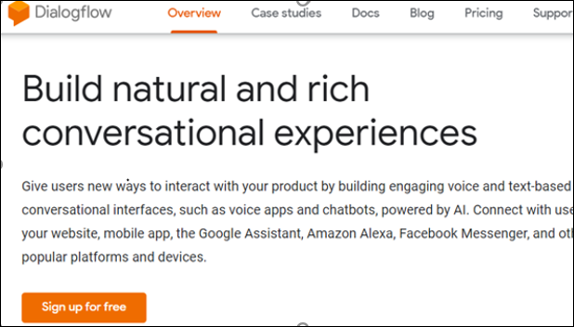

1. **Click ‘sign-in with Google’.**

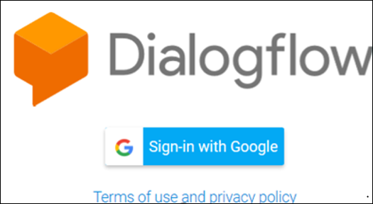

1. **Select your google account and once you are redirected, click on ‘Go To Console’ on the upper right corner of the screen.**
   1. **Dialogflow Console:**

**Manin options of google dialogflow are:**

* **Create Agents**
* **Create Intents**
* **Create entities**
* **Fulfillment to connect to other APIs.**
* **Integrate the bot with other platforms**

1. **Building a chatbot using google Dialogflow**
   1. **The problem statement:**

**A bot which is able to track live data of covid-19 casses from api and provide to user**

* 1. **Agent:**

**It is just like a project where all intents, fullfilments and settings are saved.**

* + 1. **Creating an Agent:**
  1. ***Create Agent* .**

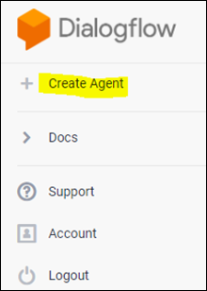

* 1. ***SAVE* .**

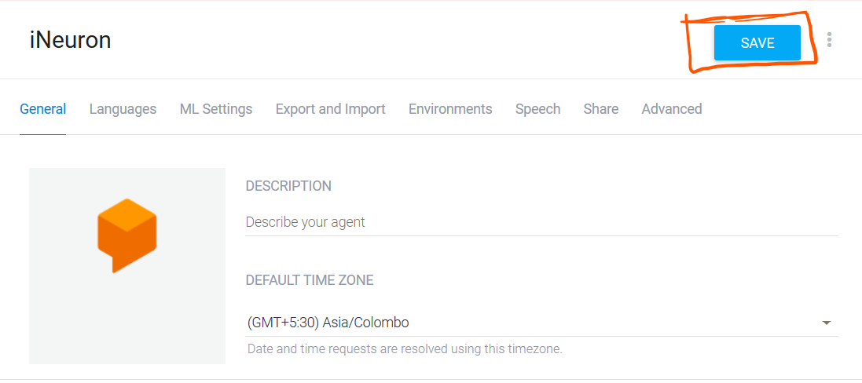

* 1. **Settings.**

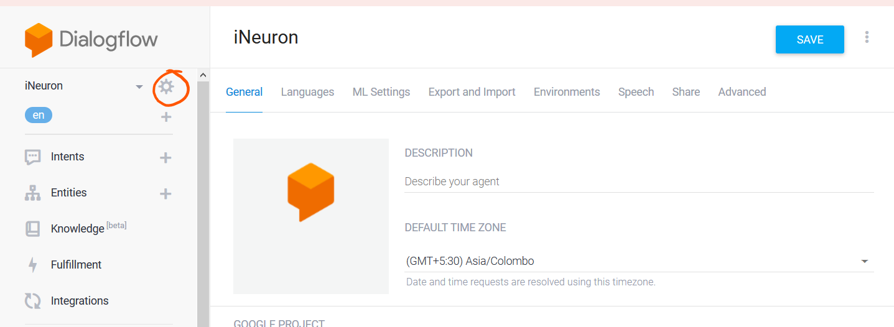

* 1. **Intent:**

**In intents we create our conversation/ queries and solution**

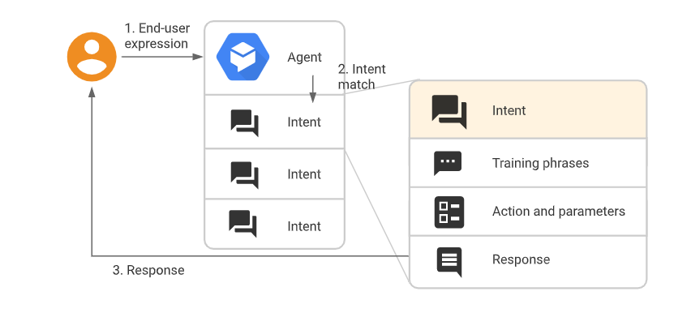

* + 1. **Creating an Intent:**
    2. **Click +add button**

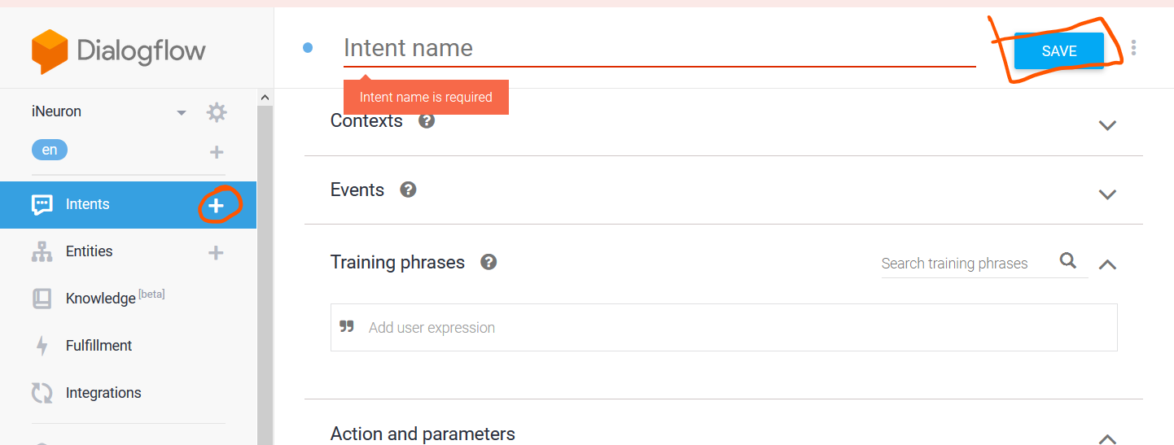

* + - 1. **Training Phrases:**

**These are queries asked by user.**

**Adding the training Phrases:**

1. **"Add user expression".**
2. **Type your training phrases and press the Enter key after each.**

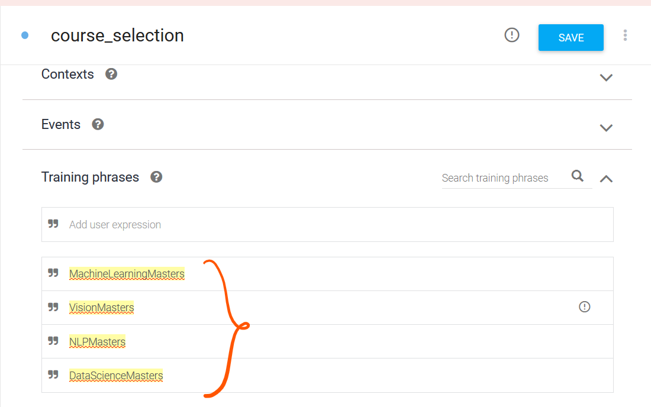

* + - 1. **Extracting the Entities:**

**You can add entities or use systen entites and double click on training phase to add entity**

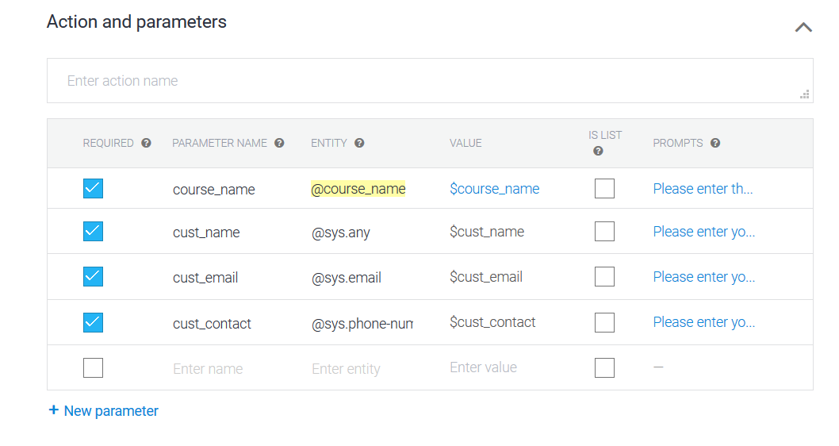

* + - 1. **Specifying custom Responses:**

**These are response given by bot. You can add phrases in renponse tab**

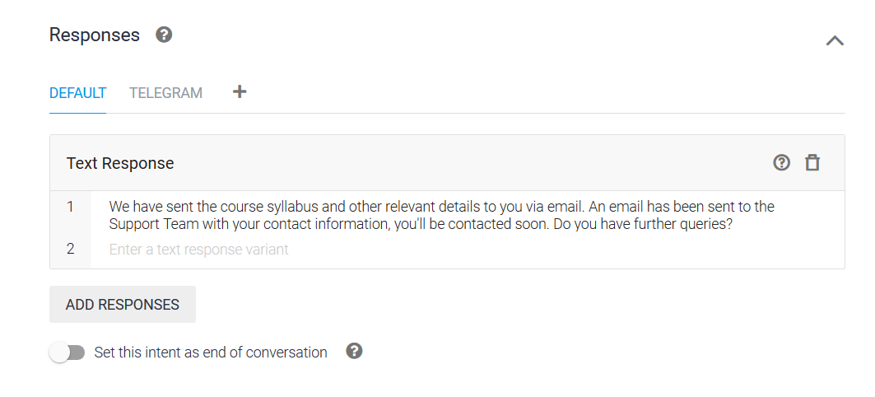

* 1. **Fulfillment:**

**If you want smarter agent you need to use fullfillments.**

**It is used to get live data from api**

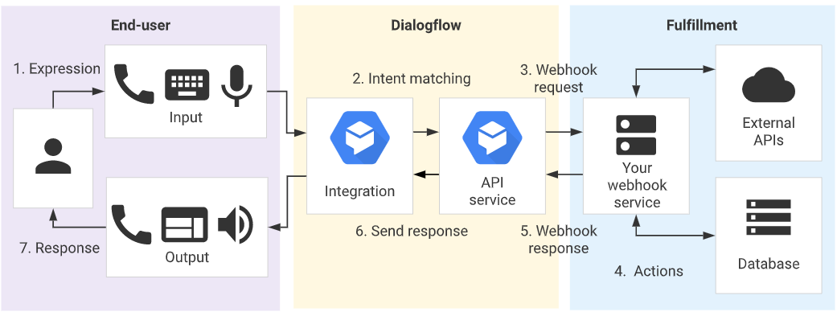

**The entire code for fulfilment can be found at** [**https://github.com/RitikDutta/COVID_Chatbot**](https://github.com/RitikDutta/COVID_Chatbot)

* + 1. **Functionalities achived in fulfilment:**
  1. **User can ask for cases in any city in India.**
  2. **User can ask current cases of india.**
  3. **User can check if user is infected with covid virus by answering some questions**
  4. **User can report a case**
  5. **Email will be sent to support team and one copy to user**
     1. **Webhook for fulfilment:**
     2. Fulfillment**.**
     3. WebhookEnabled**.**
     4. **Provide the details.**
     5. Save**.**

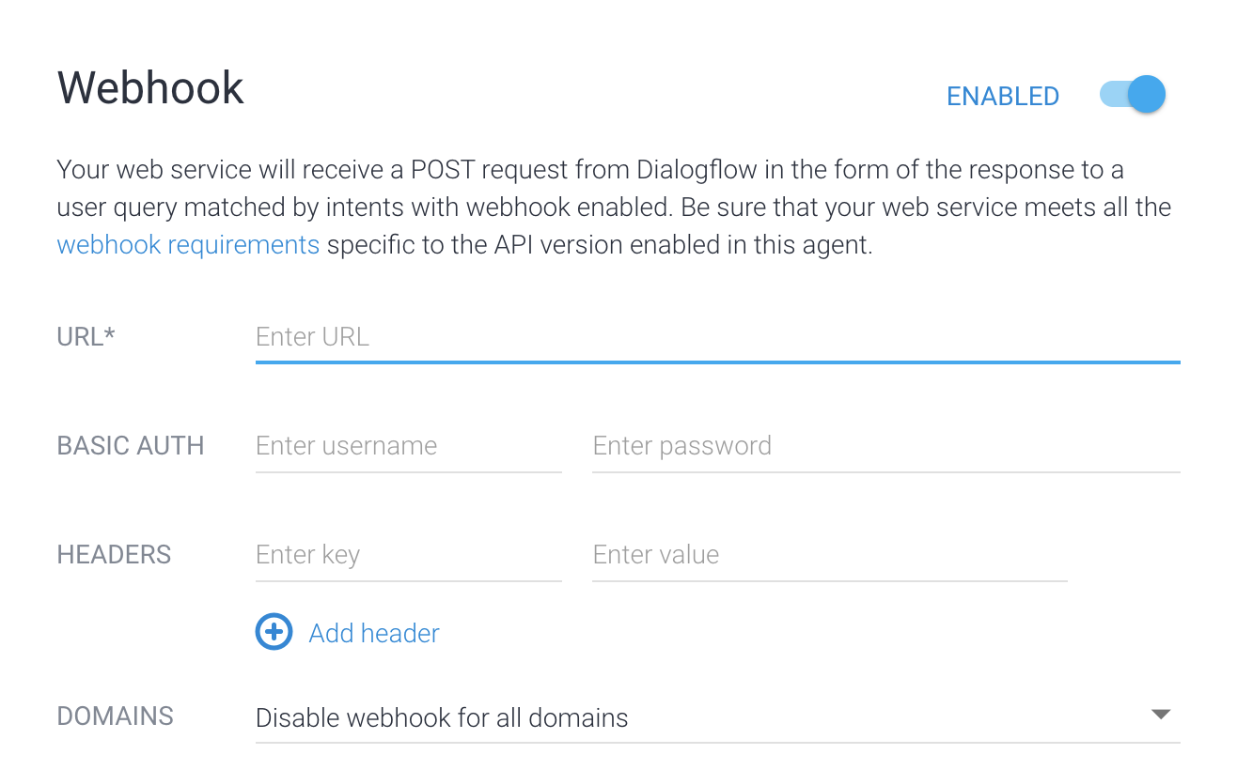

* + 1. **Fulfilment Request and Response:**

**Diagnostic info button.**

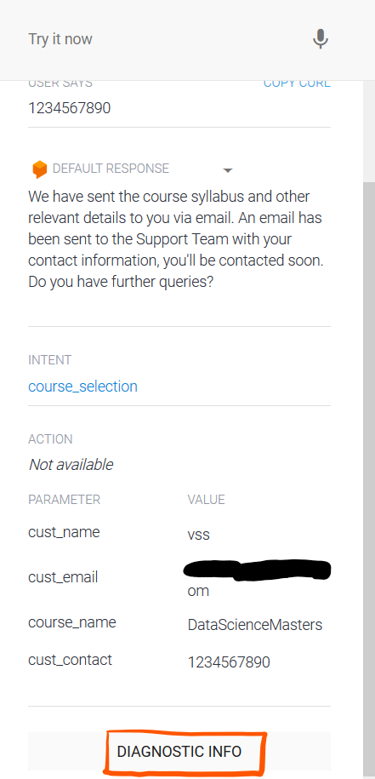

**After clicking, you’ll see the following structure:**

**{**

**"responseId": "81990e05-d8b6-420e-9235-821d0c0a0541-eec93b43",**

**"queryResult": {**

**"queryText": "cases in ajmer rj",**

**"parameters": {**

**"geo-state": "Rajasthan",**

**"geo-city": "Ajmer"**

**},**

**"allRequiredParamsPresent": true,**

**"fulfillmentText": "confirmed cases in Ajmer: 106 \nRescent cases: 3",**

**"fulfillmentMessages": [**

**{**

**"text": {**

**"text": [**

**"confirmed cases in Ajmer: 106 \nRescent cases: 3"**

**]**

**}**

**}**

**],**

**"intent": {**

**"name": "projects/covid-awareness2-tvfape/agent/intents/48aace9d-ece7-4f5c-a06e-9cd29fee7fee",**

**"displayName": "covid_cases"**

**},**

**"intentDetectionConfidence": 1,**

**"diagnosticInfo": {**

**"webhook_latency_ms": 111**

**},**

**"languageCode": "en"**

**},**

**"webhookStatus": {**

**"message": "Webhook execution successful"**

**}**

**}**

**The Request above gives you the idea of how to parse the requests in your webhook service.**

* 1. **Knowledge base:**

**It is used to add some FAQ queries**

* + 1. **Creating a Knowledge base**

1. **CREATE KNOWLEDGE BASE.**

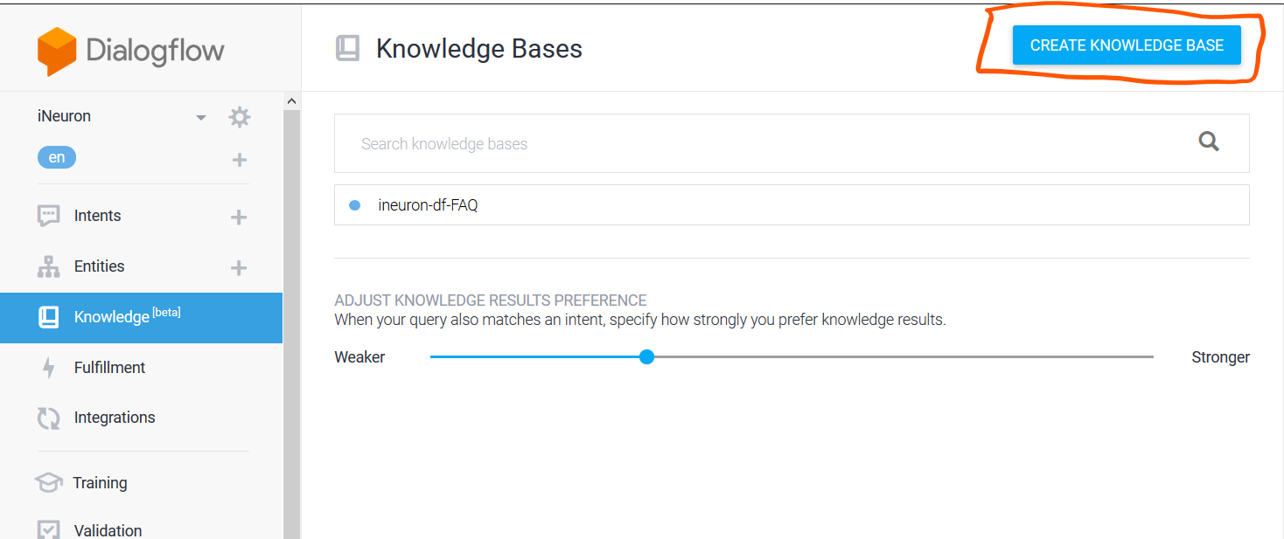

1. **Save.**
2. **Once created, you’ll see a message stating that no knowledge document has been created yet. Click ‘create the first one’ to start creating your document.**

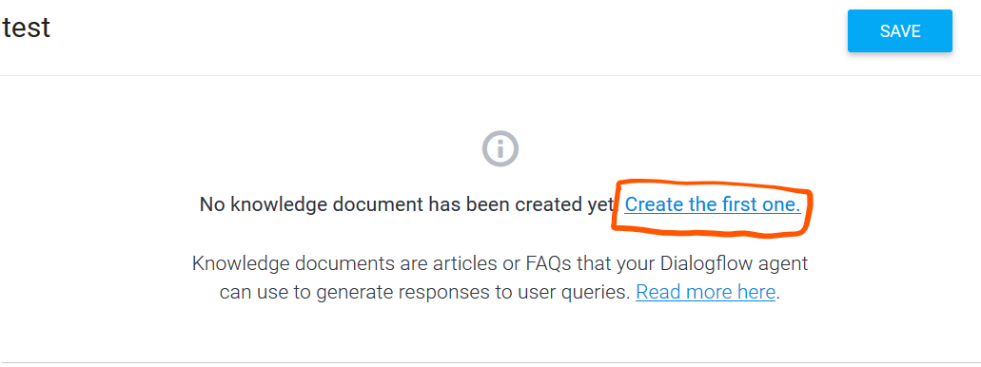

1. **Select FAQ and text/CSV and the upload the FAQ CSV file created and then click Create.**

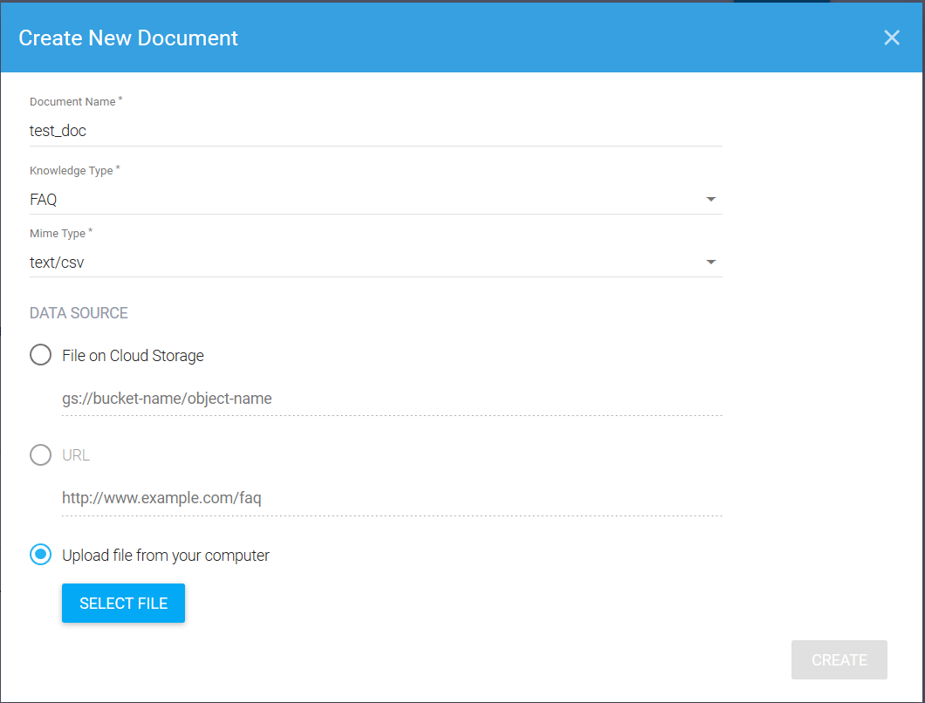

1. Responses **section and add responses as desired:**

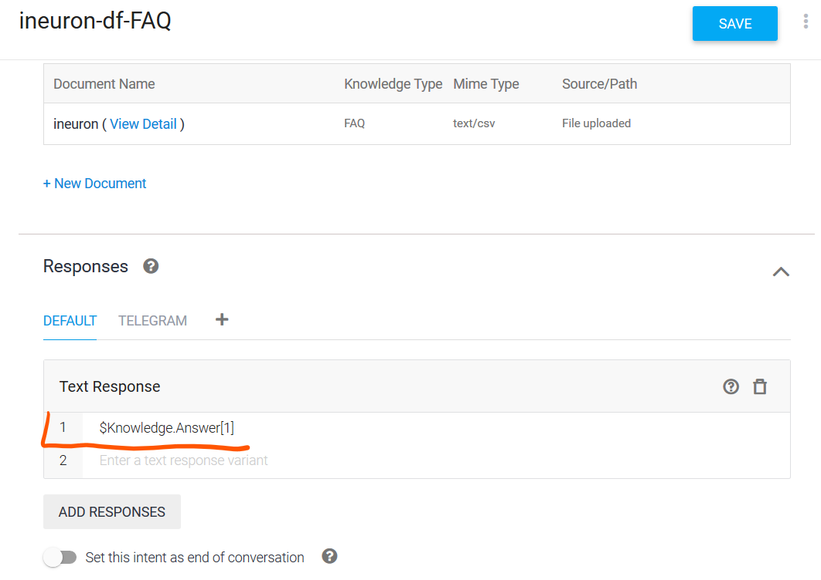

1. **SAVE.**
   1. **Test the Agent:**

**You can now test the agent from the ‘test it now’ section.**

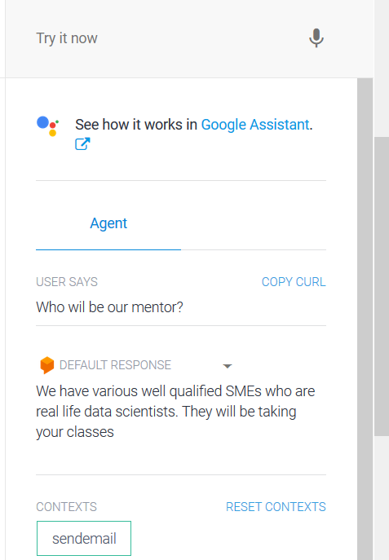

* 1. **Integration:**

**You can add dialogflow to different technologies like telegram, whatsapp, website, etc.**

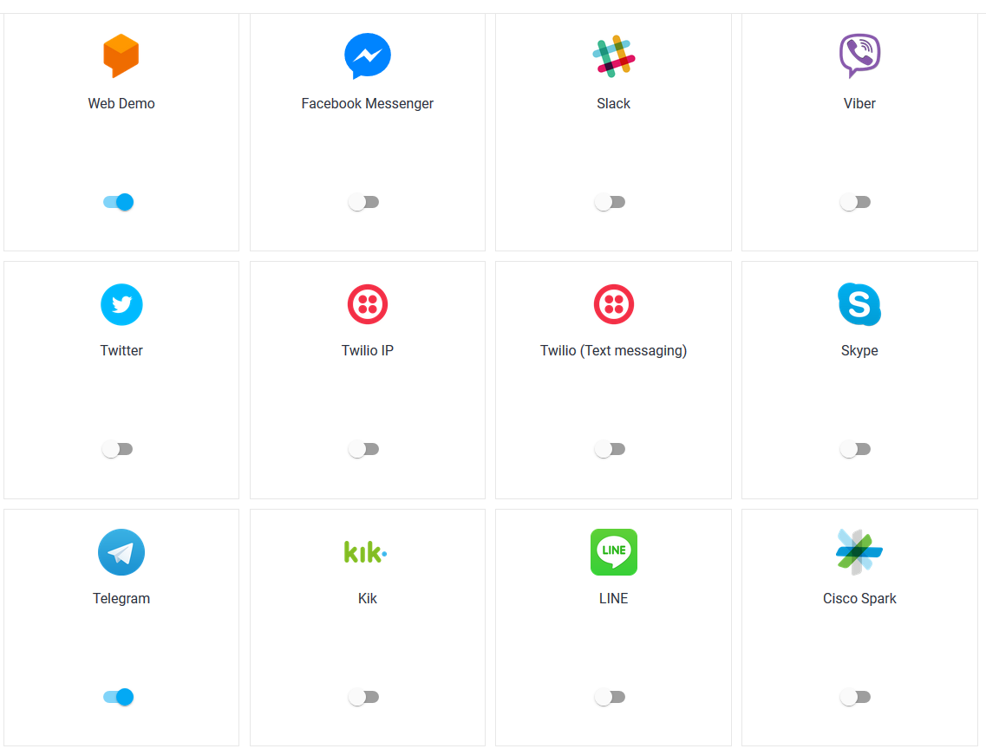

* + 1. **Integration with Telegram:**

**Dialogflow Telegram Integration allows you to easily create Telegram bots with natural language understanding based on the Dialogflow technology.**

**In order to set up the Telegram integration for your agent, you'll need the following:**

1. [Telegram account](https://web.telegram.org/" \l "/login).

### **3.7.1.2 Creating a Bot in Telegram**

1. **Login to Telegram and go to** <https://telegram.me/botfather>
2. Start
3. /newbot
4. **Enter a username for the bot, ending in "bot" (e.g. garthsweatherbot)**
5. **Copy the generated access token**

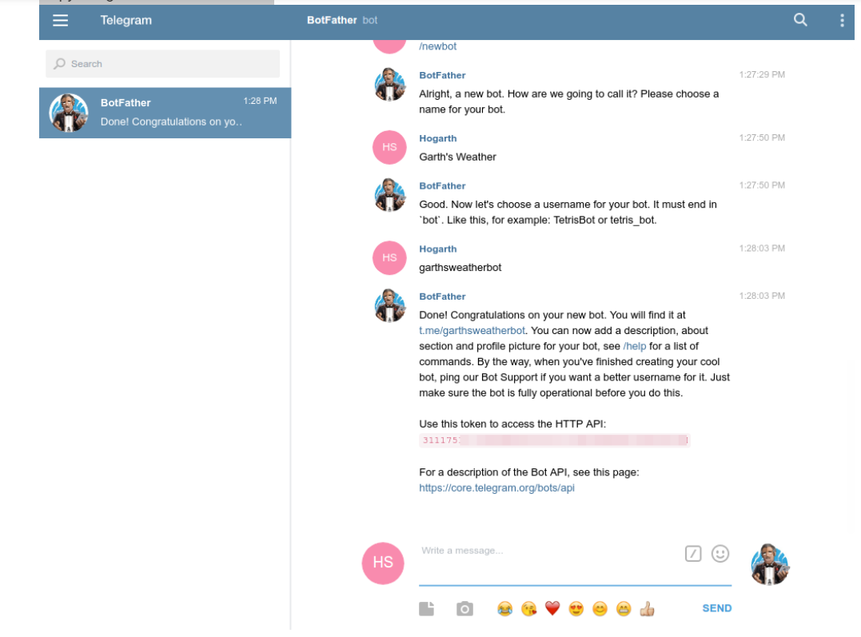

## **3.7.1.3 Setting Up Dialogflow**

1. **Go to Integrations**
2. **Click on the Telegram tile**
3. **Paste theAccess Token**
4. **Click the Start button**

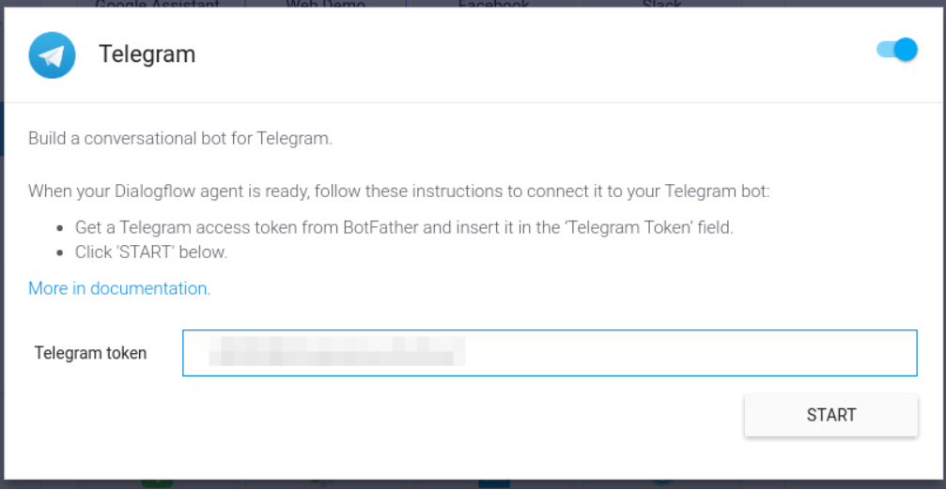

**Now you can search your bot in telegram and you can chat with it.**

